**Server Hosting Installation Step-by-step:**

**Fetch the sources:**

$ git clone https://github.com/<xyz>/enterprise.git

**Database setup:**

**Tables:  
*Customers Information Dashboard [1]***

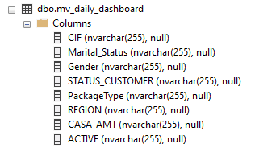

***Machine Learning Conversion and Retention Score [2]***

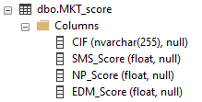

**Views:**

***Tracking Incentive 🡨 [1]***

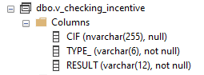

***Marketing Campaign Assistant 🡨 [1] & [2]***

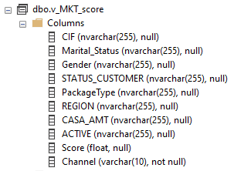

***\*\* The fields for each tables as well as the query scripts for view might vary depending on the business requirements at the time of production deployment***

**APIs’ setup:**

**Running**

$ cd <source code location>

$ cd APICombine

$ npm start

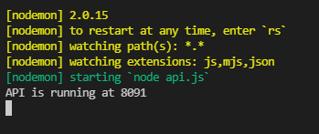

We have 3 API components running on port 8091 ([localhost:8091/api/](http://localhost:8091/api/incentive))

+ Fetching data of cross-check incentive results view: [localhost:8091/api/incentive](http://localhost:8091/api/incentive)  
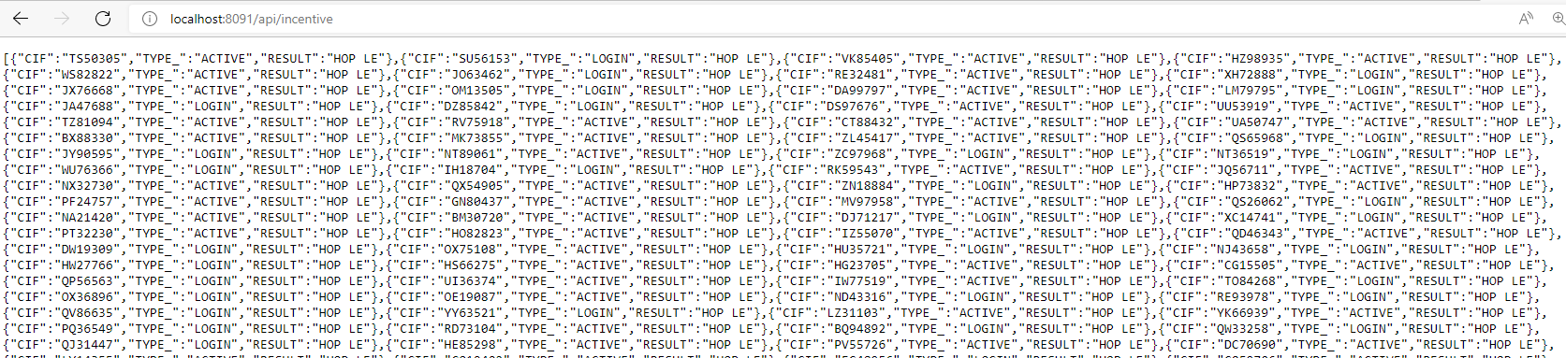

+ Fetching data of cross-check incentive results view: [localhost:8091/api/mkt](http://localhost:8091/api/mkt)  
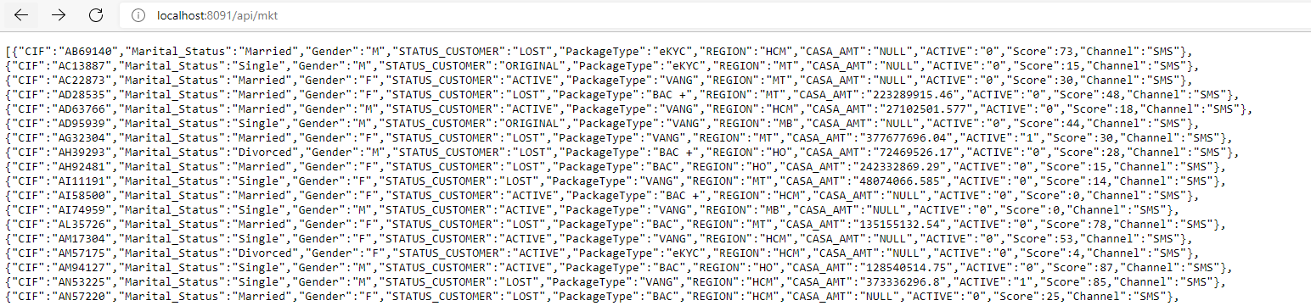

+ Fetching and posting data for login session: 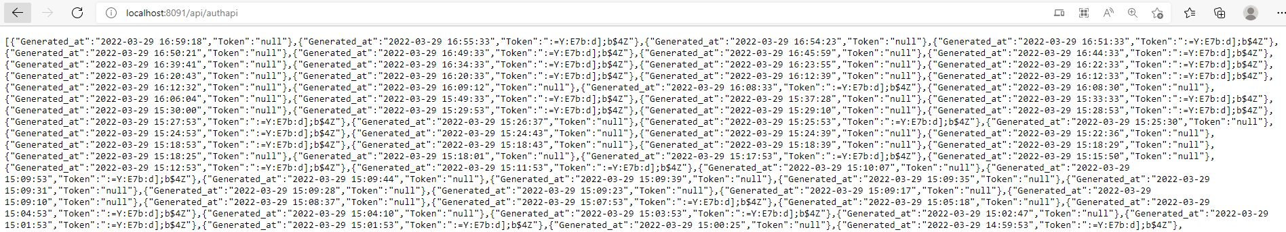

**Testing**

Use Postman or any API methods supporting IDE to testing the API

+ Get methods for Incentive Tracking and Marketing Campaign Assistant and Authentication Sessions API:



+ Post method for Authentication Sessions API:

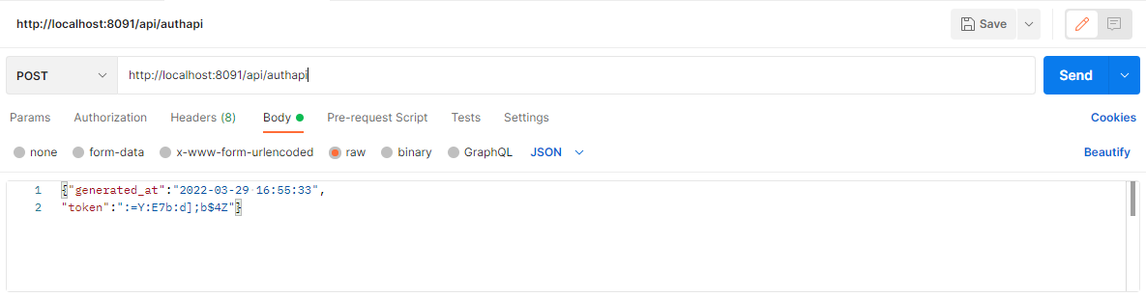

***Body format:***

{"generated_at":"yyyy-mm-dd HH:mm:ss",

"token":"<token/null>"}

**Homepage’s setup:**

$ cd <source code location>

$ cd my-app/my-app

$ npm start  
  
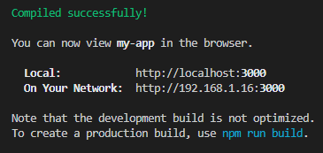

**Components’ setup:**

**Incentive Tracking:**

$ cd <source code location>

$ cd TrackingIncentives/inc-track

$ npm start  
  


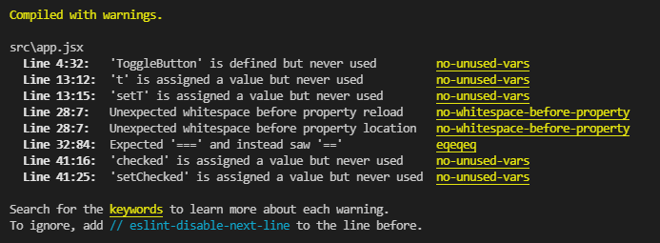

**Marketing Campaign Assistant:**

$ cd <source code location>

$ cd TrackingIncentives/MKT

$ streamlit run app.py

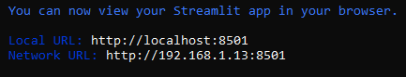

**Batch Machine Learning Scheduler**

1. Make sure you logged on as an **administrator** or you have the same access as an administrator.
2. **Start** 🡪 **Control Panel** 🡪 **System and Security** 🡪 **Administrative Tools** 🡪 **Task Scheduler**
3. **Action** 🡪 **Create Basic Task** 🡪 Type a name and Click Next
4. Follow through the wizard.  
   + Initialize name and description  
   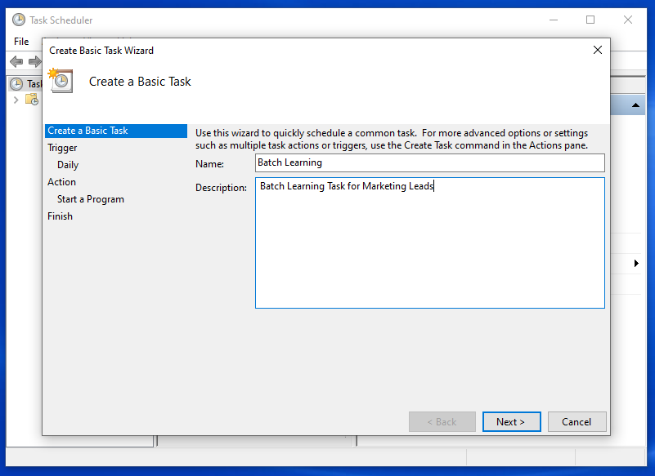  
     
   + Setup the frequency and timing   
   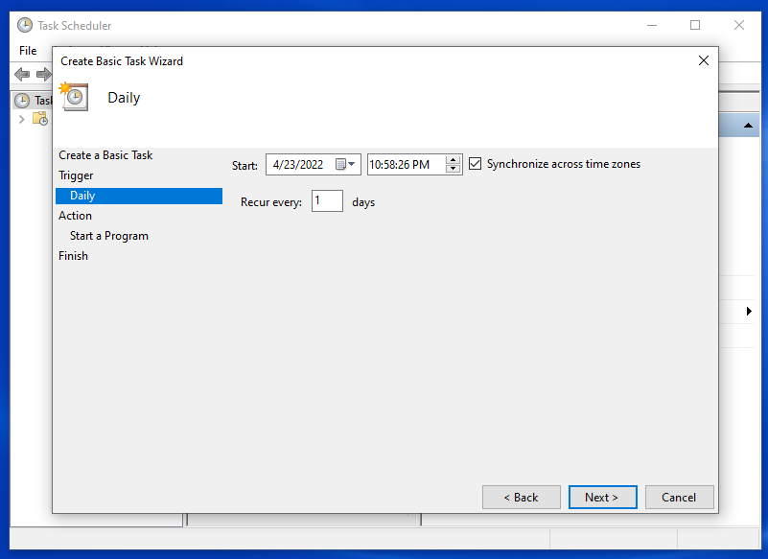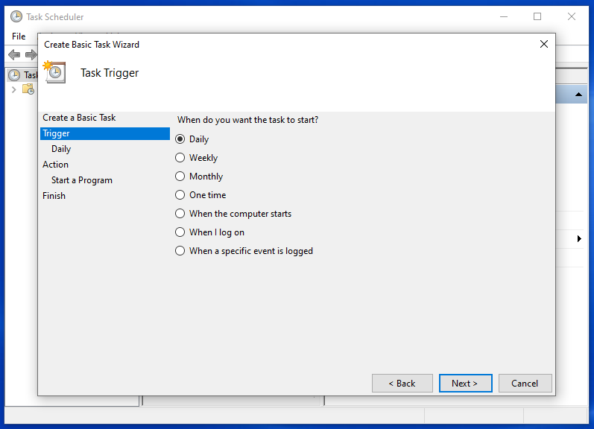  
     
     
     
     
     
     
     
     
     
     
     
     
     
     
     
     
   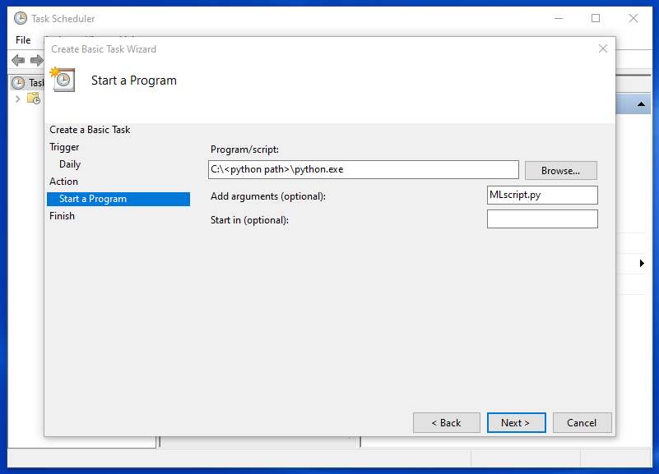+ Set up the scripts to run python program

+ Check the details of task for finalizing  
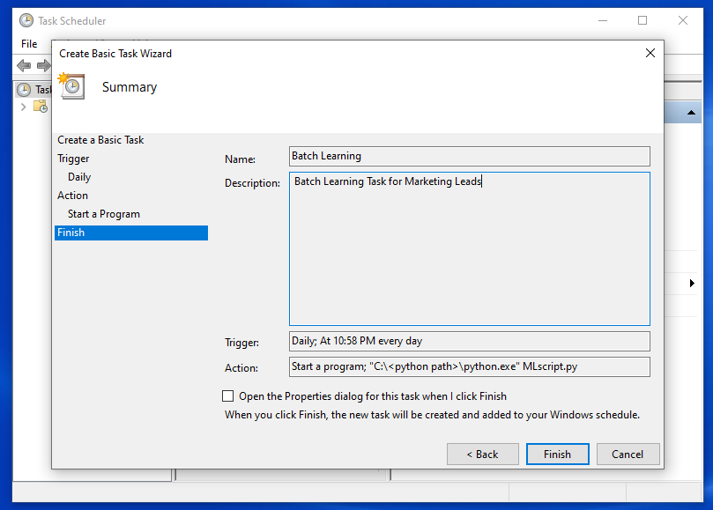  
🡪 Finish

**Network’s setup:**

***\*\* The process might be different from one to another depending on network provider. However, they all follow the same pattern***

**LAN (Local Area Network):**

On our office, networks router uses NAT (Network Address Translation) to allow internal devices to share a single external IP4 Address.

External computers or devices only see the public IP address that is assigned to the NAT router while Internal network are private addresses and are only routable within LAN (Local Area Network).

Meanwhile, devices within the same LAN can see and access the others on network defined rules.

In the hosting device,

Open **Start** > **Settings** > **Network & Internet** > **Status**

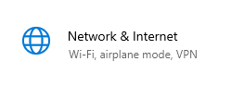

**🡪** 🡪 🡪

Choose **Network and Sharing Center 🡪 Change advanced sharing settings**

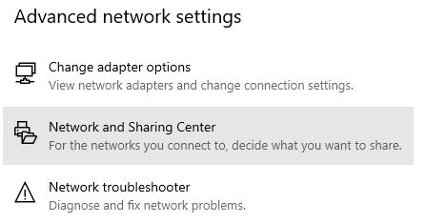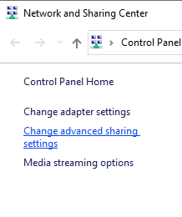

**Turn on automatic setup of network connected devices**

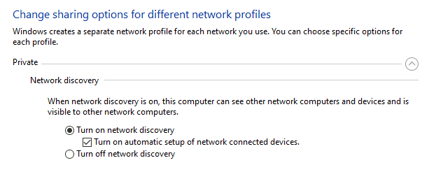

**VPN (Virtual Private Network):**

The OCB VPN server has already been set up.  
Client computers wants to join the Network follows these steps:  
1. Access [**https://sslvpn.ocb.com.vn**](https://sslvpn.ocb.com.vn) and login by your OCB business authentication  
2. Choose the suitable installer package and download it

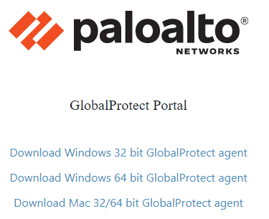

3. Connect VPN

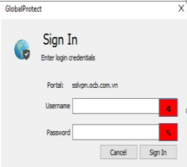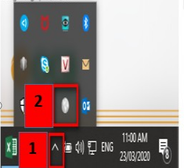 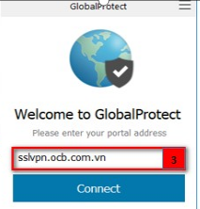

Click on the VPN icon, input **sslvpn.ocb.com.vn**, then use your authentication to log in

4. After successfully log into the VPN, open the terminal and use ‘**ipconfig’** to see whether you get access onto the Ethernet

5. Now you could access to the hosting server IP to use the services